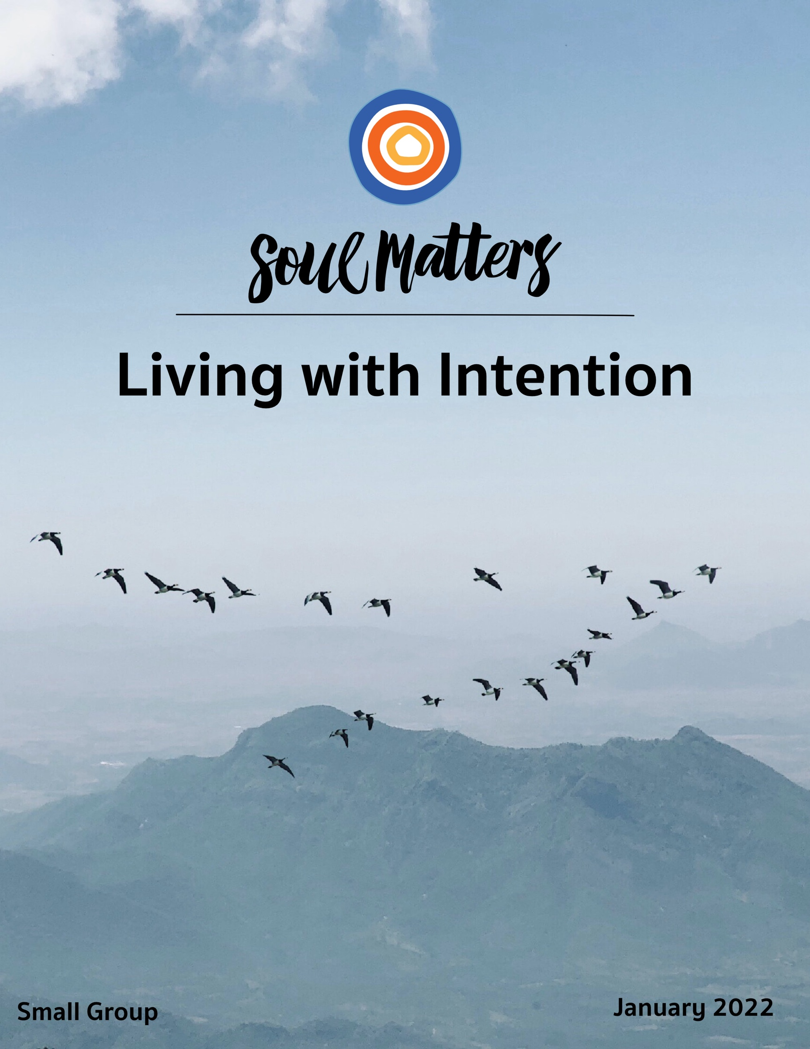

Welcome to Living with Intention

“Here’s what I discovered. Intention is different from setting goals or resolutions in that it “pulls us into” who we truly are. Goals and resolutions “push us out” into future possibilities. To set intentions, we must listen to our inner voice which tells us who we truly are.”
- Katie Covey, Soul Matters Director of RE Resources

So here we are again, in the month of January, with its talk of daring resolutions and demanding calls to become better. It’s hard to resist. After all, who of us couldn’t benefit from a bit of self-improvement? And so most of us gladly go along and declare “This is the year I’m finally going to be a better me!”

But are we sure this is what we really want? When you read that quote above about being “pulled in” rather than “pushed out,” what happens in your heart? Is being pushed really what you want and need? Are you really excited about the New Year’s work of striving to create a brand new you? Or do you suddenly notice an internal whisper that says, “I long to be pulled in more deeply to the self I already am”? In other words, maybe our real New Year’s work is not about pushing forward into self-improvement, but about pausing, stepping back and asking, “What hunger has my heart?”

There is, after all, a big difference between becoming better and becoming ourselves. Self-improvement is not the same as self-alignment. Wanting to get from point A to point B is something quite different from longing to find your inner anchor. Bottom line: Goals and intentions may indeed be more distinct than we have thought. And being clear about that may be more important than we have thought.

So this month, maybe our most meaningful work is to make room. All around us this month, there’s going to be tons of talk about creating goals and imagining who we might become. But living with intention seems to be more about creating a quiet space that allows us to connect with who we already are, a space that protects us from the pressure to accomplish and instead makes room to ask questions of integrity.

And if we are able to carve out that quieter space, then maybe we will discover that this isn’t the year of “finally becoming a better me.” Maybe we’ll decide it’s enough to simply “finally be me.”

Process

Prior to the Meeting

- Please make time to engage with this document at least 1-2 weeks prior to each meeting.
- Select and complete one of the spiritual exercises.
- Reflect on the list of questions and pick the one that speaks most directly to you. Try to “live with” that question for a week or two. Make the question a part of your meditative practice or pin it somewhere you can see it each day.
- Set aside time to look over recommended resources (“Companion Pieces”). You may also want to follow the Soul Matters Facebook page. This extra reading and Facebook engagement is optional but deepens your engagement with the themes.

At the Meeting

Meetings are usually held once a month and last for about two hours. Here is the basic meeting flow:
- Centering: We’ll begin with a chalice lighting and centering words.
- Brief Check-In: We’ll participate in a brief check-in, with each member taking 30-60 seconds to share.
- Brief Review: We’ll briefly revisit core themes in the member packet, so we can refresh our memories and bring anyone who hasn’t had the opportunity to review the materials up to speed.
- Spiritual Exercises: We’ll share our experiences engaging in one of the spiritual exercises in the packet. This sometimes takes place in two rounds for deeper reflection.
- “Your Question” Discussion: We’ll share our experiences answering our chosen question in the packet, engaging in two rounds if time permits.
- Check-Out: We’ll each briefly summarize our experience in Small Group by sharing a few words.
- Closing: We’ll extinguish the chalice and end with a brief reading or blessing.

Group Covenant

At the first meeting, we’ll review and affirm our covenant. Some of the practices important to Small Group Ministry include:
- Maintaining confidentiality
- Doing more listening than talking, allowing everyone an opportunity to participate
- Avoiding interrupting others, offering advice, passing judgment or correcting
- Supporting one another inside and outside of Small Group Ministry

Our Spiritual Exercises

Option A

Filling In The Blanks With Intention

It’s not easy to stay true to your deepest intentions. But often it’s even harder to figure out what they are. This exercise assumes that our deepest self already knows our core intentions and our work is to decipher what it wants us to hear. To help, you are invited to access and download this document. It contains uncompleted sentences. Fill them in, then step back and see if you notice any patterns or surprises in them. When filling in the blanks, trust your instincts. In other words, don’t spend a lot of time pondering what to put in the blank. Instead just write down the first or second thing that pops in your head. Think of it as a Rorschach test on intention.

After you complete the sentences on the linked page, use these questions to help you reflect on the answers you wrote in the blanks:

- What would you change after giving the completed sentences a second look?
- What surprises you?
- Would your closest friend or partner agree with how you filled in the blanks? (Maybe even ask them!)
- What 2 or 3 sentences seem to merit your greatest attention right now?
- What single intention are you ready to make based on listening deeply to what the list of completed sentences is trying to tell you?

Come to your group ready to share the 2-3 questions that you engaged the most and why that was so. And if you are comfortable, consider telling the group what single intention you set based on the exercise.

Option B

Start Your Day with Intention

“At the beginning of the day, the mind is most open to receive new impressions. One of the most important things we can do is to take full responsibility for the power of the morning.”
- Marianne Williamson

“Your day is pretty much determined by how you spend your first hour.” - Anon

This exercise invites you to explore the power of intentional mornings. Too often our days take hold of us rather than us taking hold of them. So, for at least one week, pick one of the practices listed on this page to begin your day with a greater sense of intentionality and purpose.

Option C

Just Eat!

Multitasking is king. All of us do it. It’s become a habit. Just the way things are. In other words, we are now multitasking unintentionally! So this month, let’s intentionally try doing one thing at a time, or as some people say, let’s try single tasking! Here’s your challenge in a nutshell:

Pick one thing you usually do while multitasking and
instead do it, and it alone, each day for a week!

So many options to choose from. The obvious one, of course, is eating. That’s right, pick one meal a day and do nothing but eat. No watching TV at the same time. No checking your email as you chomp down. Just intentionally eat and focus on your food. Or maybe narrow it a bit more and single-task with your first cup 0f coffee or tea each morning. For ten minutes just do nothing but sip. Ten bucks says you will notice the aroma in your nose and heat on your tongue in a way you’ve not in a long time. Some of us will choose to do a chore without our usual distraction of listening to a podcast while wash the dishes or sweep the floor. Others may apply this practice to our morning commute and just sit and ride. No newspaper reading or headphones in. When you walk the dog, just do that! When you shower, just shower. When you shave, just shave. When you pet your dog, just pet your dog. You get the point. The challenge is picking the one thing you will do each day for a week.

Researchers say that when we single-task, even for just ten minutes a day, depression decreases and happiness increases. We also remember and notice more. In other words, when we intentionally focus on what we are doing, our lives don’t just become happier, they become richer. Not a bad deal for ten minutes a day!

Option D

Which Quote is Yours?

In the Companion Pieces section below, there are many quotes about the practice of living with intention. Engaging these quotes and finding the one that especially speaks to you is a spiritual practice in and of itself.

So, as your spiritual exercise for this month, reflect on those quotes until you find the one that most expands or deepens your understanding of living with intention.

After you’ve found it, consider writing it out on a small piece of paper and carrying it with you or pinning it up so you can continue to reflect on it throughout the weeks leading up to your group meeting. Come to your group ready to share where the journey led you.

Your Question

Don’t treat these questions like “homework” or try to answer every one. Instead, make time to meditate on the list and then pick the one question that speaks to you most. The goal is to figure out which question is “yours.” Which question captures the call of your inner voice? And what is that question trying to get you to notice or acknowledge?

Often it helps to read the list to a friend or loved one and ask them which question they think is the question you need to wrestle with!

- What did your parents intend to do with their lives? Did they fulfill it? And whether they did or didn’t, what did you learn from watching them try?

- What is your intention when you wake up? Some begin the day by asking, “What do I have to get done?” Others ask, “What do I want this day to be about?” Which are you?

- Are you too intentional? Is it time to put down all the “doing” and pay a bit more attention to “being”? Has your long list of intentions left you feeling exhausted and even lost?

- They say intention arises from within. So, what do you do to stay in touch with the fire in your belly?

- They say intention takes pause. So, when was the last time you stopped, stepped back and allowed yourself to ask, “Am I going in the right direction?”

- They say, “Habits eat good intentions for breakfast.” So, what new habit might you put in place that enables your intentions to become real?

- What if it’s not about what you intend to do with life, but about what life intends to do with you?

- Have you ever felt that life was living you rather than you living it?

- Is it finally time to give up that unrealistic intention? The one you’ve failed at following through on again and again? The one you’ve been beating yourself up over, again and again? Is it time to intentionally be gentle with yourself and let it go?

- Are you as good at assuming the good intentions of others as you are at defending your own?

- What’s your question? Your question may not be listed above. As always, if the above questions don't include what life is asking from you, spend the month listening to your days to find it.

Companion Pieces

Recommended Resources for Personal Exploration & Reflection

The following resources are not required reading. We will not analyze these pieces in our group.
Instead they are here to companion you on your journey this month, get you thinking
and open you up to new ways of imagining the spiritual practice of Living with Intention.

Word Roots & Definitions

From Latin intentus: "to stretch out, lean toward” and Latin intendere: ‘intend, extend, direct’, from in- ‘towards’ + tendere ‘stretch, tend’.

This is usually understood as reaching for and pursuing a goal. But it can equally refer to stretching towards something within us. A moving closer to our internal compass and values. A stretching toward authenticity. A stretching toward our true selves.

Wise Words

Before you tell your life what you intend to do with it, listen for what it intends to do with you. Before you tell your life what truths and values you have decided to live up to, let your life tell you what truths you embody, what values you represent.
Parker J. Palmer

Between stimulus and response there is a space. In that space is our power to choose our response. In our response lies our growth and our freedom.
Viktor E. Frankl

In any given moment we have two options, to step forward in growth or to step back into safety.
Abraham Maslow

When I dare to be powerful — to use my strength in the service of my vision, then it becomes less and less important whether I am afraid… I am deliberate and afraid of nothing.
Audre Lorde

Intention is the difference between those old mustard stains and Jackson Pollock.
Anon

Intentional living is the art of making our own choices before others’ choices make us.
Richie Norton

Those who follow the crowd usually get lost in it.
Rick Warren

Any dead fish can go with the flow — you have to be intentionally alive to swim against the current.
Ann Voskamp

I had at least begun to guess that my greatest need might be to let go and be free from the drive after achievement — if only I dared. I had also guessed that perhaps when I had let these go, then I might be free to become aware of some other purpose that was more fundamental, not self-imposed private ambitions but something which grew out of the essence of one’s own nature. People said: ‘Oh, be yourself at all costs.’ But I had found that it was not so easy to know just what one’s self was. It was far easier to want what other people seemed to want and then imagine that the choice was one’s own.
Marion Milner, quoted in A Life of One’s Own

I want to stop transforming and just start being.
Ursula Burns

At the center of your being, you have the answer; you know who you are, and you know what you want.
Lao Tzu

With goals, the future is always the focus: Are you going to reach the goal? Will you be happy when you do? What's next? Setting intention, at least according to Buddhist teachings, is quite different than goal making. It is not oriented toward a future outcome. Instead, it is a path or practice that is focused on how you are "being" in the present moment… Goals help you make your place in the world and be an effective person. But being grounded in intention is what provides integrity and unity in your life... What would it be like if you didn't measure the success of your life just by what you get and don't get, but gave equal or greater priority to how aligned you are with your deepest values?
Phillip Moffitt

Cat: Where are you going?
Alice: Which way should I go?
Cat: That depends on where you are going.
Alice: I don’t know.
Cat: Then it doesn’t matter which way you go.
Lewis Carroll, Alice in Wonderland

I always wanted to be somebody, but now I realize I should have been more specific.
Lily Tomlin

A person will worship something, have no doubt about that. We may think our tribute is paid in secret in the dark recesses of our hearts, but it will out. That which dominates our imaginations and our thoughts will determine our lives, and our character. Therefore, it behooves us to be careful what we worship, for what we are worshipping we are becoming.
Ralph Waldo Emerson

We are what we pretend to be, so we must be careful about what we pretend to be.
Kurt Vonnegut

Conscious change is brought about by the two qualities inherent in consciousness – intention and attention… Whatever you put your attention on will grow stronger in your life. Whatever you take your attention away from will wither, disintegrate and disappear.
Deepak Chopra
Habits eat good intentions for breakfast.
John Ortberg

“Sacred space” is another way of saying “with intention.”
S. Kelley Harrell

That's the sacred intent of life, of God--to move us continuously toward growth, toward recovering all that is lost and orphaned within us and restoring the divine image imprinted on our soul.
Sue Monk Kidd

All I know is that my life is better when I assume that people are doing their best. It keeps me out of judgment and lets me focus on what is, and not what should or could be.”
Brené Brown

A Prayer of Good Intention
Dear Lord,
So far I've done all right.
I haven't gossiped,
haven't lost my temper,
haven't been greedy, grumpy, nasty, selfish, or overindulgent.
I'm really glad about that.
But in a few minutes, God,
I'm going to get out of bed.
And from then on,
I'm going to need a lot more help.
-Anon

Music

Two different playlists for each of our monthly themes: one in Spotify and another in YouTube. They are organized as a journey of sorts, so consider listening from beginning to end and using the playlists as musical meditations.

Click here for the Spotify playlist on Living with Intention
Click here for all Spotify playlists.
Click here for the YouTube playlist on Living with Intention
Click here for all the YouTube playlists.

Videos & Podcasts

Resolutions: I Promise - Spoken Word Poem
Natalie Patterson
https://www.youtube.com/watch?v=kuEShiLy4MA

Today I'm Gonna Try and Change the World
https://www.youtube.com/watch?v=ccm_6HwlUbs

Turning Mass Intention Into Mass Action
Todd Rogers
https://www.youtube.com/watch?v=Fn82cNy52a4
The three secrets of turning intention into action: making a plan, applying peer pressure and reinforcing identity!

What Will Your Verse Be?
https://www.youtube.com/watch?time_continue=85&v=R_zsMwCOoEs
Excerpted from the film Dead Poets Society

How To Simplify Your Life
https://www.youtube.com/watch?v=7lECIsRif10&t=159s
On the need to intentionally create a quieter life.

Articles

Intent vs. Impact: Why Your Intentions Don’t Really Matter
Jamie Utt
https://everydayfeminism.com/2013/07/intentions-dont-really-matter/

How to 80/20 Your Life
https://markmanson.net/80-20-your-life?utm_source=pocket_mylist
On how to intentionally focus on those small parts of our life that produce most of the meaning.

Books

The Power of Habit
Charles Duhigg
How to intentionally change your habits and take back your life.

Our Time Is Now
Stacey Abrams
A blueprint to harness collective intention and energy to end voter suppression, empower our citizens, and take back our country

More Monthly Inspiration from Soul Matters!

Our Facebook Inspiration Page:
https://www.facebook.com/soulmatterssharingcircle/

Our Instagram Page:
Find us as “soul_matters_circle”

Music Playlists:
Click here for links to the Spotify playlists for each month.
Click here to check out the YouTube playlists.

Find support for bringing the
monthly themes home and into your family life with
Soulful Home: A Guide for Families:
https://www.soulmatterssharingcircle.com/soulful-home.html

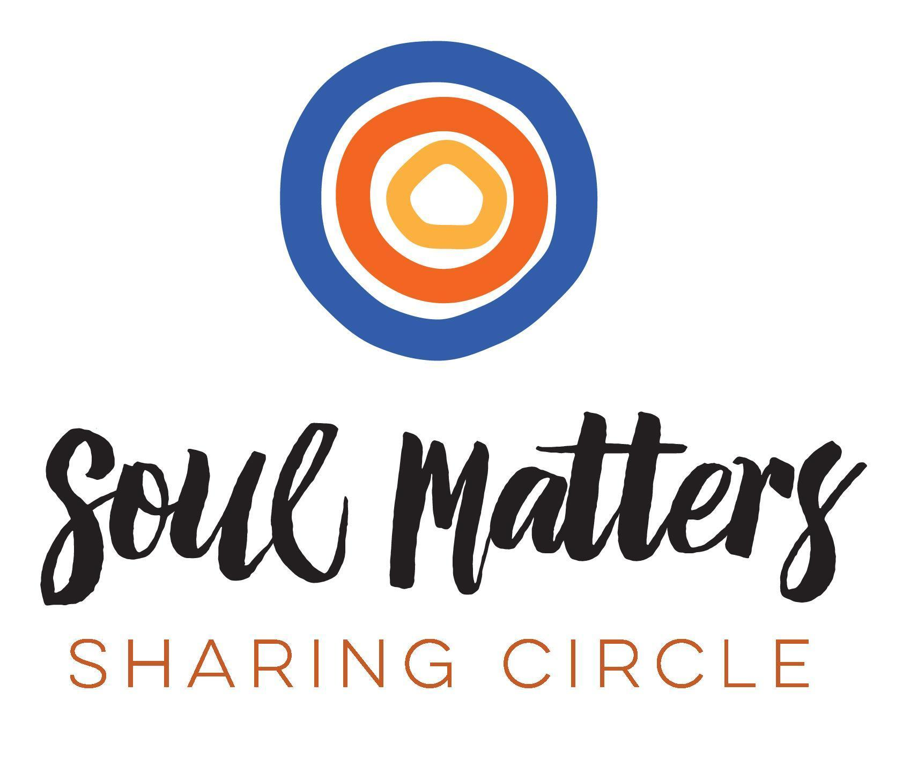
© 2021-22 Soul Matters ALL RIGHTS RESERVED

Packets are for use only by member congregations of the Soul Matters Sharing Circle.
Learn how to join at
https://www.soulmatterssharingcircle.com

